To: Thai - Hong Kong Trade Association
E-mail: thai-hongkong@thta.or.th
Fax: 02 343 9029
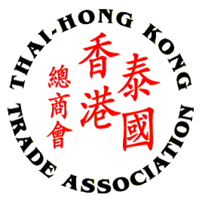

THTA CHINESE NEW YEAR CELEBRATION 2015
Thursday, 5th March 2015 from 18.00 - 22.00 hrs.
Evergreen Hall, Evergreen Laurel Hotel Bangkok

Ticket Price: 1,680 Baht per erson
16,800 Baht per table of 10 persons

No. | Name - Surname | Company Name | Position
1
2
3
4
5
6
7
8
9
10

Name of Contact :___________________________________________________________
Company : ________________________________________________________________
Address : __________________________________________________________________
___________________________________________________________________________
Tel : __________________________________ Fax : _______________________________
Email :____________________________________________________________________

Remark: Please kindly confirm your participation by returning this registration form to THTA Office via E-mail: thai-hongkong@thta.or.th or Fax: 02 343 9029 by Monday, 2nd March 2015

***************************************************************************

I/We would like to reserve_____table(s) or_____seat(s), totaling THB____________

Payment shall be made by:

Cash at the Thai-Hong Kong Trade Association

Transfer of amount to “Thai-Hong Kong Trade Association” Account at Krungthai Bank, Queen Sirikit National Convention Center Branch, Saving A/C no. 009-1-72633-6

*Please email or fax the payment slip to THTA indicating your name, address and PP. 20 (Tax ID no.) for the tax invoice and tax receipt.

